**COMMAND LINE TOOL FOR NETWORKING**

Date: 26/03/2024

1. ping

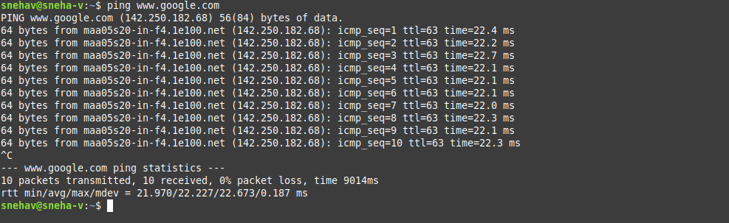

1. traceroute

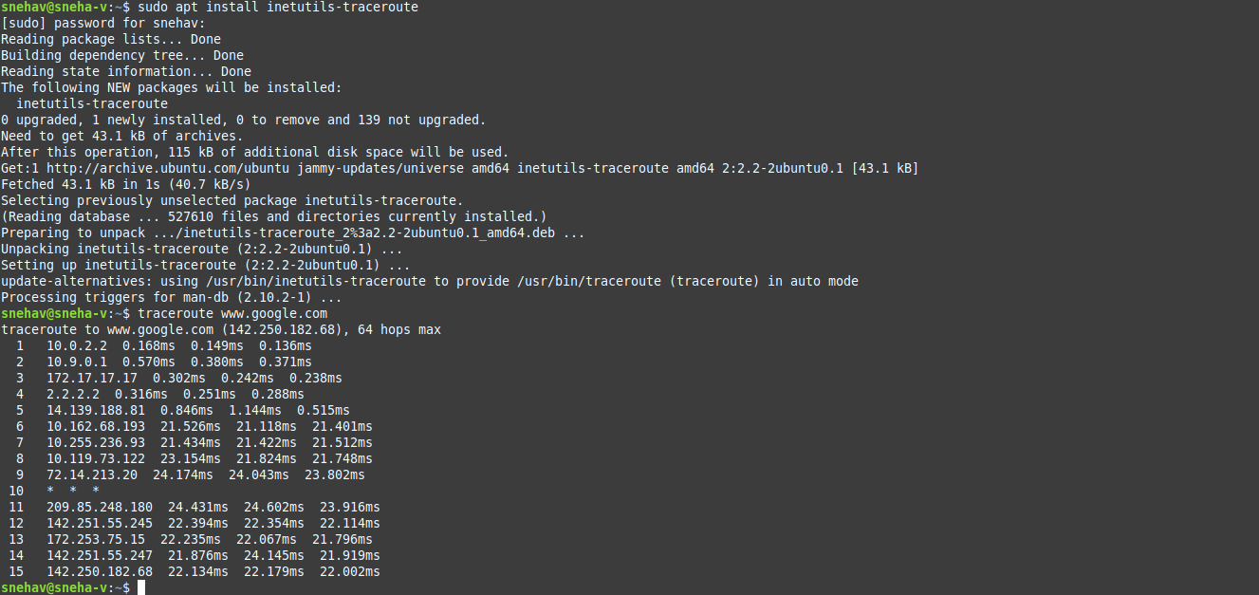

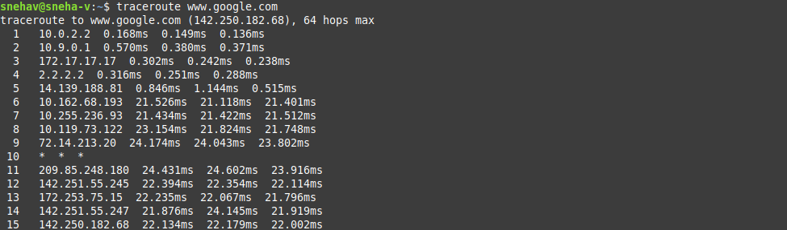

1. netstat



1. tcpdump

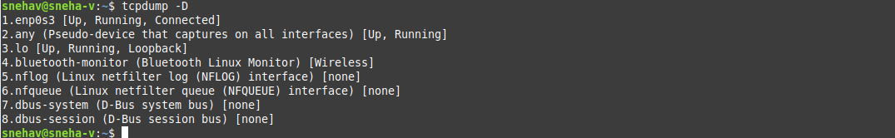

1. Ip route



1. Nslookup

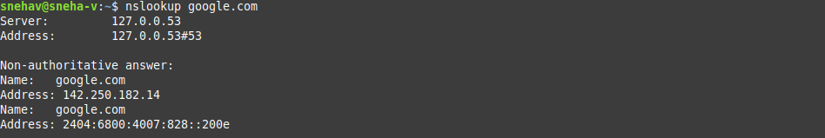

1. route

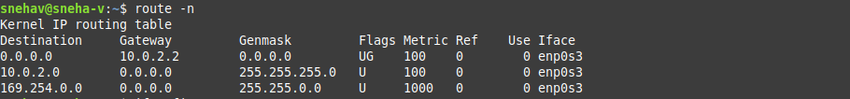

1. ifconfig

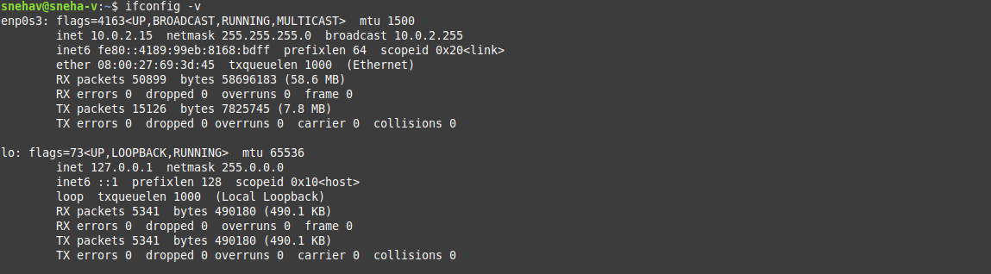

1. ifquery , ifup

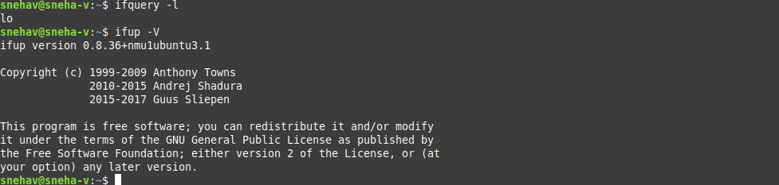

1. curl

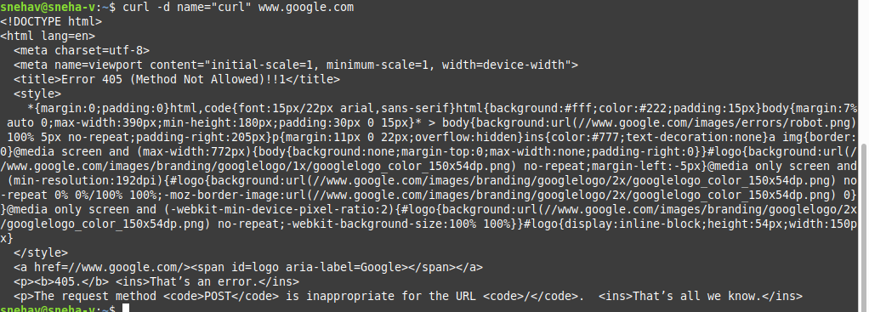

1. wget

